REPORT on the mission of the TEMPUS project (The international scientific and practical conference "HR management in the system of higher education: experience and prospects of development")
September 28 – October 2, 2015 (Almaty)
On september 28 – October 2, 2015 was held the International scientific and practical conference "HR management in the system of higher education: experience and prospects of development" at T. Ryskulov New Economic University of Almaty with the participation of the representatives of the institutions of higher education, member countries of Bologna Process.
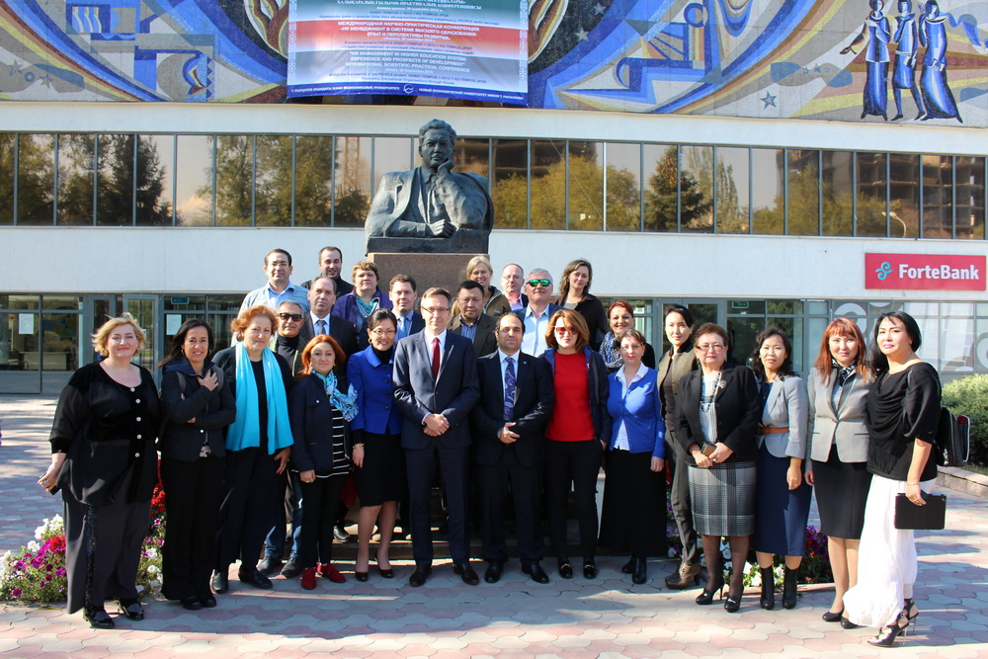
The participants of the event were the employees of our Universitys Director of HR Management Department, TEMPUS Project Coordinator D. Doskozhin and Specialist of HR Management Department, Project Manager N. Bek.
The conference was also attended by the partners:
· Polytechnic University of Catalonia, Barcelona, Spain
· Higher Technical Institute, Lisbon, Portugal
· Royal Institute of Technology, Stockholm, Sweden
· State University of Ellijay, Georgia
· University of Kutaisi, Georgia
· Armenian State University of Economics, Armenia;
· Russian-Armenian (Slavonic) University of Armenia
· American University of Armenia
· T.Ryskulov New Economic University, Kazakhstan, the Coordinator
· Kazakh Academy of Transport and Communications, Kazakhstan
· S.Toraigyrov Pavlodar State University, Kazakhstan
The number of speakers at the conference was more than 30 people.
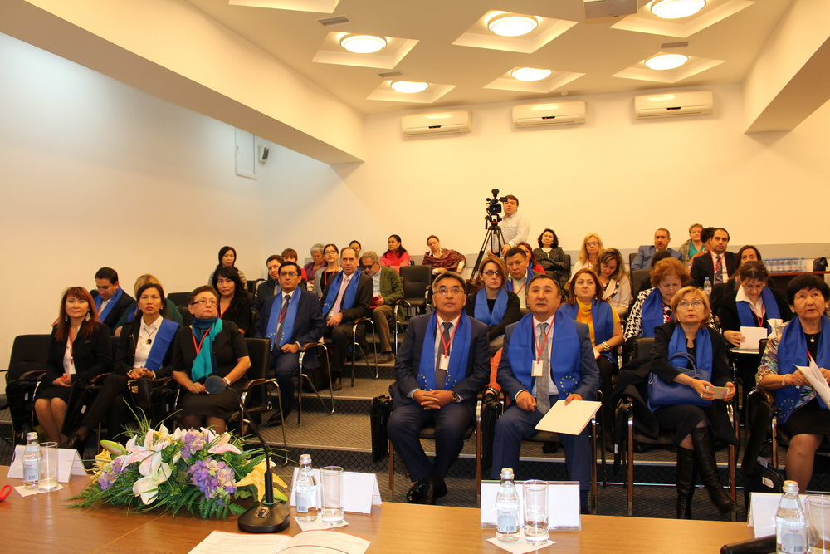
The conference was also attended by honored workers of RK and representatives of foreign institutions of higher education such as:
- Omirbaev Serik Maulenovich, Director of the Department of Higher and Postgraduate Education and International Cooperation of MES;
- Tasbulatova Shaizada Umurzakovna, Coordinator of the Erasmus + program in Kazakhstan;
- Svyatov Serik, Chairman of the Board of Directors, Head of PEOPLE project;
- Kshishtov Rybinski, Rector of T.Ryskulov NEU;
- Alicia Berlanga, European Coordinator of PEOPLE project;
- Marta Pile, Higher Technical University (Portugal);
- Charlotte Gustavson, Royal Institute of Technology (Sweden);
- Saleh Mohammad, Royal Institute of Technology (Sweden) and many other representatives of partner universities.
The objective of the conference:
- contribution to the development of higher education institutions through the systematization of approaches to the management of human resources in educational institutions;
- representation of foreign experience in development and improvement of HR management at the universities in Europe, as the results of the Project PEOPLE - 543 657 - the TEMPUS - 1 - 2013 - KZ - TEMPUS - JPGR;
- exchange of experience and constructive dialogue on the development of HR management at the universities in Kazakhstan, Georgia, Armenia, Spain, Portugal, Sweden.
During the meeting, the participants of the project had the opportunity to familiarize with the work of managers, office staff and the NEU as a whole. For our attention was presented the opened resource center where our conference with the European Project Coordinator Alicia Berlanga was held.
After the conference, the participants were awarded the certificates.

