REPORT on trip within TEMPUS project (educational training) from 27 to 31 March 2017 (Sweden, Stockholm)
10 April 2017
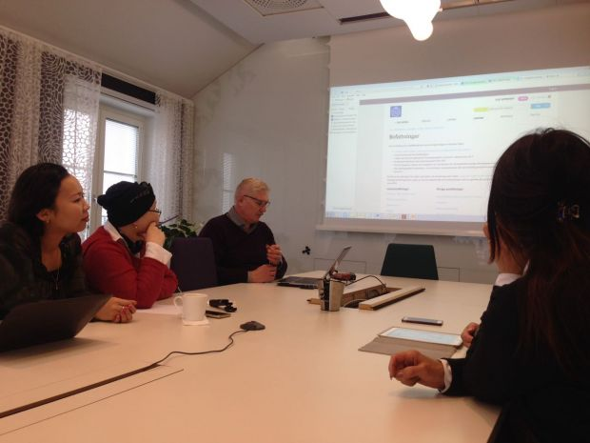
On 27-31 March 2017 at KTH Royal Institute of Technology in Stockholm was held an educational training “Human Resource Management in Higher Education”.
Employees of our university Е.А. Kravciv (Head of Department of Human Resource Management, Project Manager) and N.Y. Bek (specialist of Department of Human Resource Management, Project Manager) took part in this event.
This training was intended for the representatives of Kazakhstan partner universities and was attended by:
-Karaganda State Medical University;
-Narxoz University named after T. Ryskulov (coordinator);
-Kazakh Academy of Transport and Communications.
During the training, HR-managers of various levels of KTH University shared their experience in the field of human resource management in KTH.
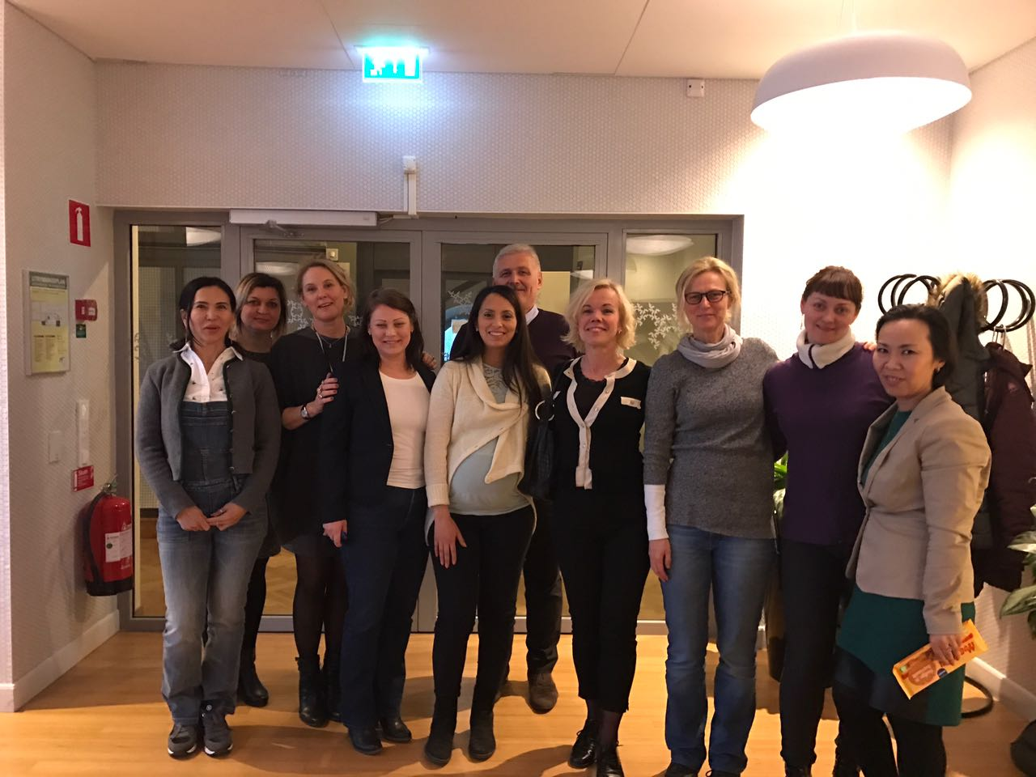
Employees of the Royal Technical University Annica Froberg (HR Director), Lotta Gustavsson (Head of Human Resources), and HR-managers of KTH faculties Jennie Reponen, Helene Hedin, Hatalia Orellana, Eva-Lotta Thomas, Anna Thoresson Berg, Maria Widlund, Ingela Hedberg, Helena Lundquist, Petra Rosenquist told about the principles of familiarization of new employees with the collective agreement in KTH, holding so-called Development dialogues and Salary dialogues, about the program of adaptation of new employees and conduction of various trainings for the university employees, about the system of incentives and motivation, recruitment processes in the university and its faculties.
At the end of the training, jointly with Viktor Kordas, Project Coordinator from the European Union, was carried out an analysis of the obtained information. The last questions on the training were asked. There was held a discussion of the preparatory work on the final conference and on the project report.
By the organizers of the seminar for the working group of event participants was conducted an excursion around the administrative building of KTH, where it was possible to see the organization of workplaces of the university staff, ask questions of interest on personnel management and get practical answers based on the work in KTH.
At the end of the training, all participants were awarded certificates.

