Report on business trip on the Tempus «Promoting educational organizations through development of people» project Barcelona, Spain
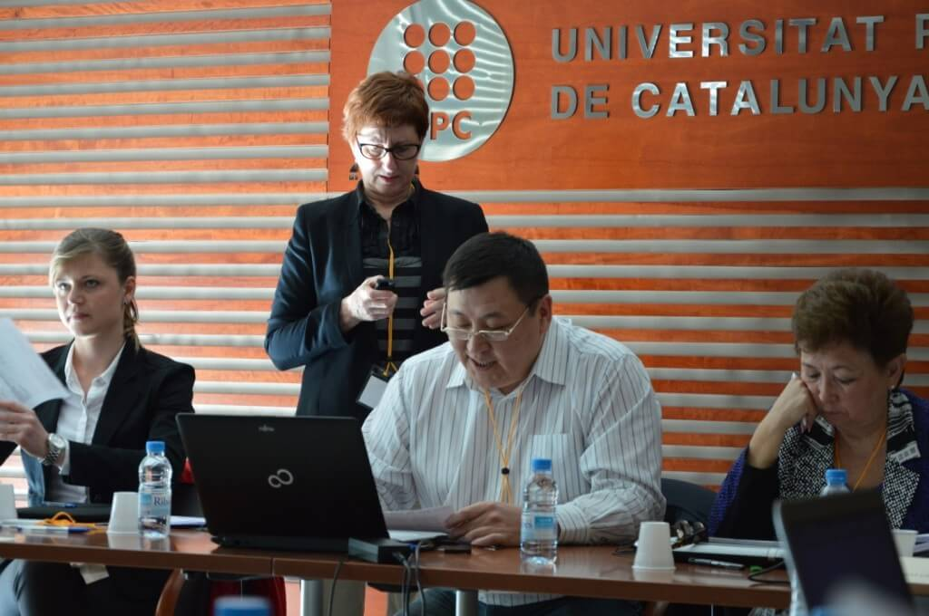
In March 10 – 12, 2014, employees of KGMU and coordinator of the Tempus «Promoting educational organizations through development of people» project D.M. Doskozhin – Director of the Center of Human Resources Management and A.Z. Muratova – Director of the Center of Management Strategy and Development within the Tempus project took part in adjusting meeting in Barcelona.
The meeting was held on the basis of the Polytechnic University of Catalonia. The meeting was also attended by:
1 Polytechnic University of Catalonia, Barcelona, Spain
2 Instituto Superior Técnico, Lisbon, Portugal
3 Royal Institute of Technology, Stockholm, Sweden
4 Ilia State University, Georgia
5 University of Kutaisi, Georgia
6 Armenian State University of Economics, Armenia
7 Russian-Armenian (Slavic) University, Armenia
8 American University Armenian Fund, Armenia
9 Ryskulov Kazakh University of Economics, Kazakhstan – coordinator
10 Kazakh Academy of Transport and Communications, Kazakhstan
11 Torajgyrov Pavlodar State University, Kazakhstan
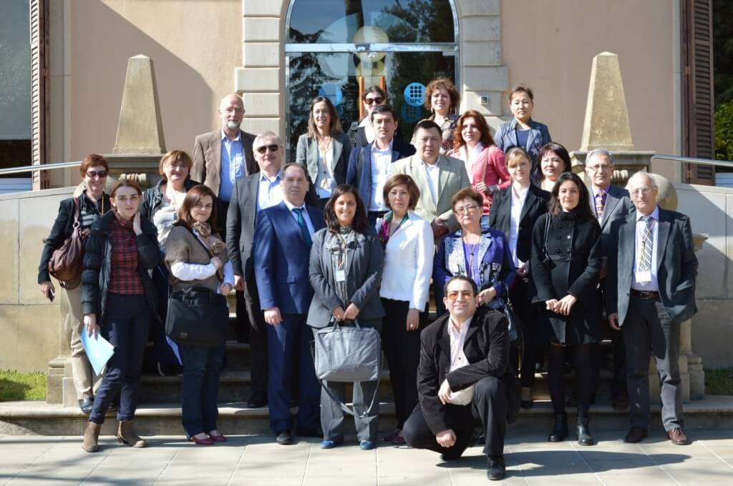
Representative of the Karaganda State Medical University demonstrated presentation about KSMU and Tempus project. The meeting was opened by the rector of Polytechnical University of Catalonia, Enrique Fossas, and also the vice rector Xavier Yinas. In the same day all partners – universities presented their presentations. The general presentation of the Tempus «Promoting educational organizations through development of people» project of Polytechnic University of Catalonia was demonstrated at the next day, then within two working days were discussed and appointed responsible persons for working packages.

