Report on business trip on the TEMPUS project (audit) June, 2014, Almaty
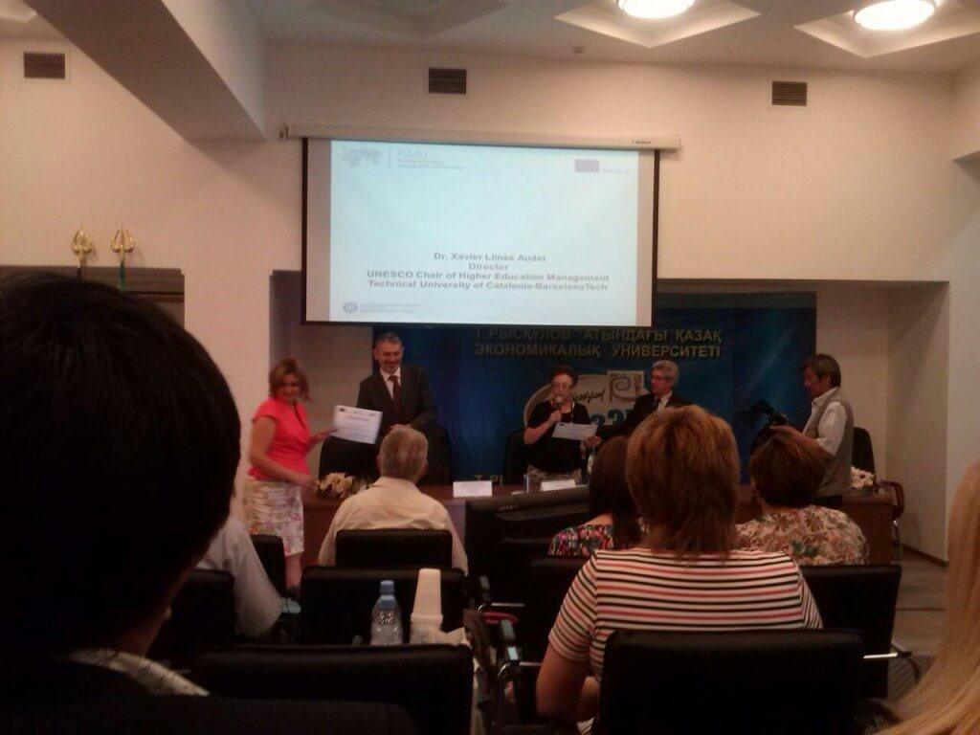
On June 8-19, 2014 employees of KGMU consisting of: Director of the Center of Human Resources Management – TEMPUS project coordinator D. M. Doskozhin, and Head of HR E.A. Kravtsiv and the HR officer G.A. Kanatbekovy became participants of audit according to the Tempus «Promoting educational organizations through development of people» which took place on the basis of the Ryskulov Kazakh University of Economics in Almaty. Audit was carried out by the project coordinator Alicia Berlanga (Polytechnic University of Catalonia) and Victor Kordash (Royal Institute of Technology). The audit considered questions about development of human resources in term of reception, training, promotion of personnel. Also participants of this trip participated in a seminar training on «Strategic Management of Universities» on ISMO «Institute on Strategic Management of Universities» project.

