Report on TEMPUS Project (seminar-training) business trip on March 3-6, 2015
On 3-6 March, a training seminar on TEMPUS “Promoting educational organizations through PEOPLE” was held on the basis of Polytechnic University of Catalonia in Barcelona. The participants were employees of our University, Director of Human Resource Management Center, TEMPUS Project Coordinator – D. Doskozhin and the Specialist of Human Resource Management Center, project manager – A. Akhmetova.

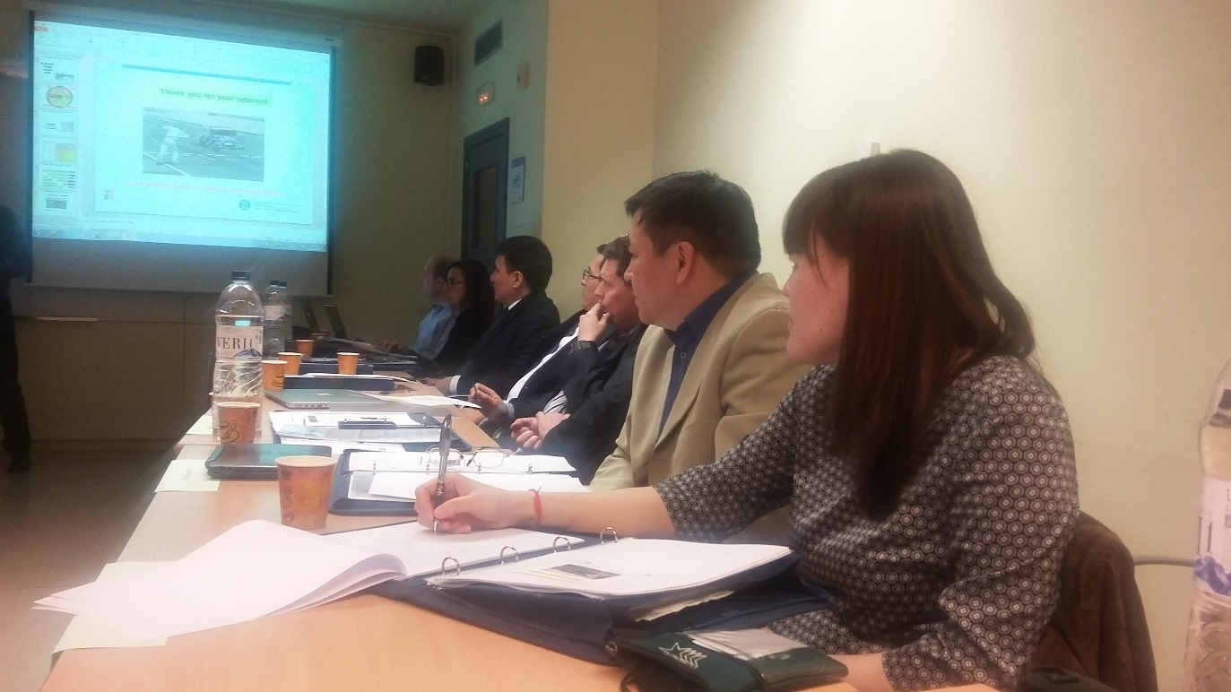

The seminar was also attended by:

- Polytechnic University of Catalonia, Barcelona, Spain
- Instituto Superior Técnico, Lisbon, Portugal
- Royal Institute of Technology, Stockholm, Sweden
- Ilia State University, Georgia
- Kutaisi University of Georgia
- Armenian State University of Economics, Armenia
- Russian-Armenian (Slavic) University, Armenia
- American University of Armenian Fund, Armenia
- New Economic University. T.Ryskulov Kazakhstan -koordinator
- Kazakh Academy of Transport and Communications, Kazakhstan
- Pavlodar State University. Torajgyrov, Kazakhstan
The main objective of this training workshop is aimed to the strategic planning of human resource development. The workshop revealed such questions as the Strategic Management, Strategic Planning and Quality, Why a strategic planning, How to involve all the university community into a strategic planning. At the end of training participants presented the exercises on strategic planning. The last day of seminar was held People steering committee on the next actions within the TEMPUS Project.

