Tempus
REPORT on the mission of the TEMPUS project (Exhibition of TEMPUS IV project results)
June 8-9, 2015. (Astana)
On 8-9 June at L.N. Gumilyov Eurasian National University, Astana, was held a Republican seminar "National frameworks of qualifications: from the methodology of architecture to practical application."
The seminar was sponsored by the Ministry of Education and Science of RK.
The participants of the event were the employees of our University Director of HR Management Department, TEMPUS Project Coordinator D. Doskozhin and Specialist of HR Management Department, Project Manager N. Bek.
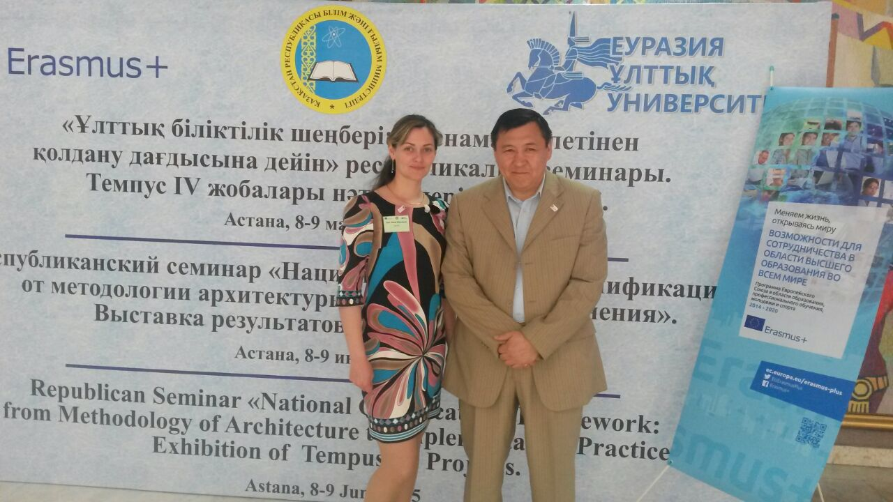
The conference was also attended by the partners:
· Polytechnic University of Catalonia, Barcelona, Spain
· Higher Technical Institute, Lisbon, Portugal
· Royal Institute of Technology, Stockholm, Sweden
· State University of Ellijay, Georgia
· University of Kutaisi, Georgia
· Armenian State University of Economics, Armenia;
· Russian-Armenian (Slavonic) University of Armenia
· American University of Armenia
· T.Ryskulov New Economic University, Kazakhstan, the Coordinator
· Kazakh Academy of Transport and Communication, Kazakhstan
· S.Toraigyrov Pavlodar State University, Kazakhstan
The members of the National Organizing Committee of the seminar were the following:
- Balykbaev Takir Ospanovich, Vice-Minister of Education and Science of RK, Chairman;
- Ismagulova Svetlana Salmenovna, Deputy Director of the Department of Higher and Postgraduate Education and International Cooperation of MES RK;
- Tasbulatova Shaizada Umurzakovna, Erasmus + Program Coordinator in Kazakhstan, Deputy Chairman;
- Nurmanbetova Jamilya Nusupzhanovna, First Vice-Rector of L.N.Gumilyov Eurasian National University, Vice-Chairman;
- Abylaikhan Akerke, Deputy Director of the Department of Higher and Postgraduate Education and International Cooperation of MES RK;
- Narbekova Banu Mukataevna, Head of Content Management and Education Methodology of the Department of Higher Postgraduate Education and International Cooperation of MES RK;
- Nurmagambetov Amantay Abilhairovich, Director of the Center of Bologna Process and Academic Mobility;
- Omirbaev Serik Maulenovich, Director of Academic Affairs of the Independent Kazakhstan Quality Assurance Agency in Education, the member of NT of EHER.
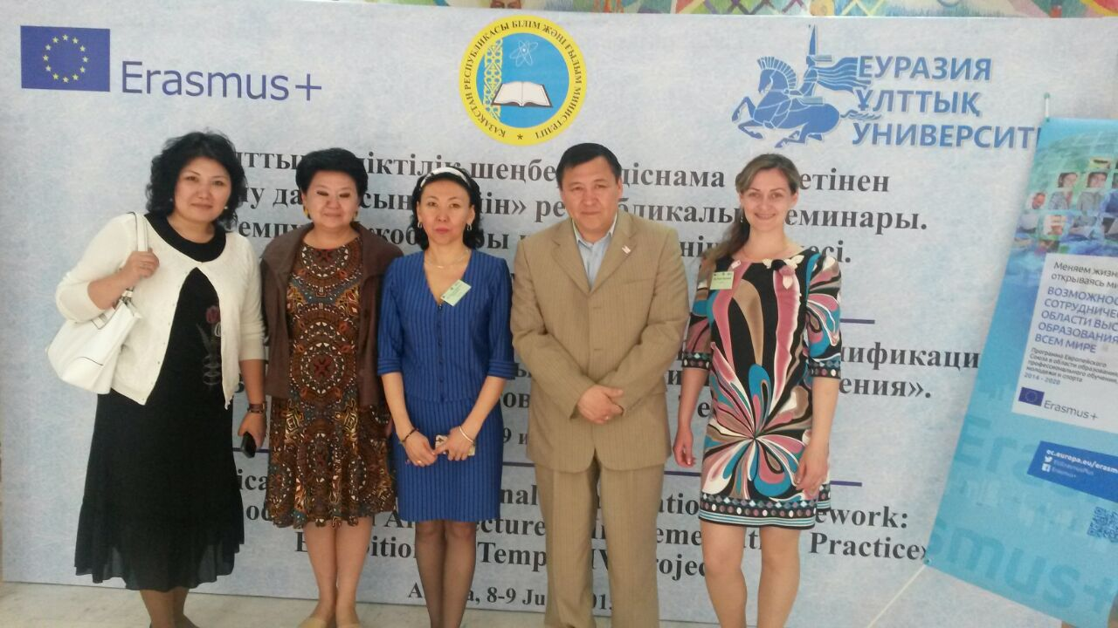
The seminar was opened by the exhibition of the results of Tempus IV, for participation in which the representatives of the projects (both projects that have been completed and still in progress) prepared and brought to the attention of the judges the material of the projects and the work done in the framework of the programs. One of the judges was Jean-Louis Lavroff, the Head of Technical Cooperation Department of the European Union Agency in the Republic of Kazakhstan.
The objective of the seminar:
Familiarization of the representatives of institutions of higher education of Kazakhstan and other concerned organizations with some aspects of the modernization of higher education of the concerned European countries.
The task of the exhibition:
Discussion of the main results of the TEMPUS projects in Kazakhstan.
By the end of the second day of the seminar there was a presentation of diplomas to the winners of the exhibition.
As a result of the work of the exhibition, the team of PEOPLE project on "Promotion of educational organizations development through human development''was awarded the diploma of II degree "For meaningful and diverse presentation of the results at the exhibition," and the team itself was awarded the diploma "For the well-coordinated work."

