- Go to cos.kgmu.kz link.
- Choose the language

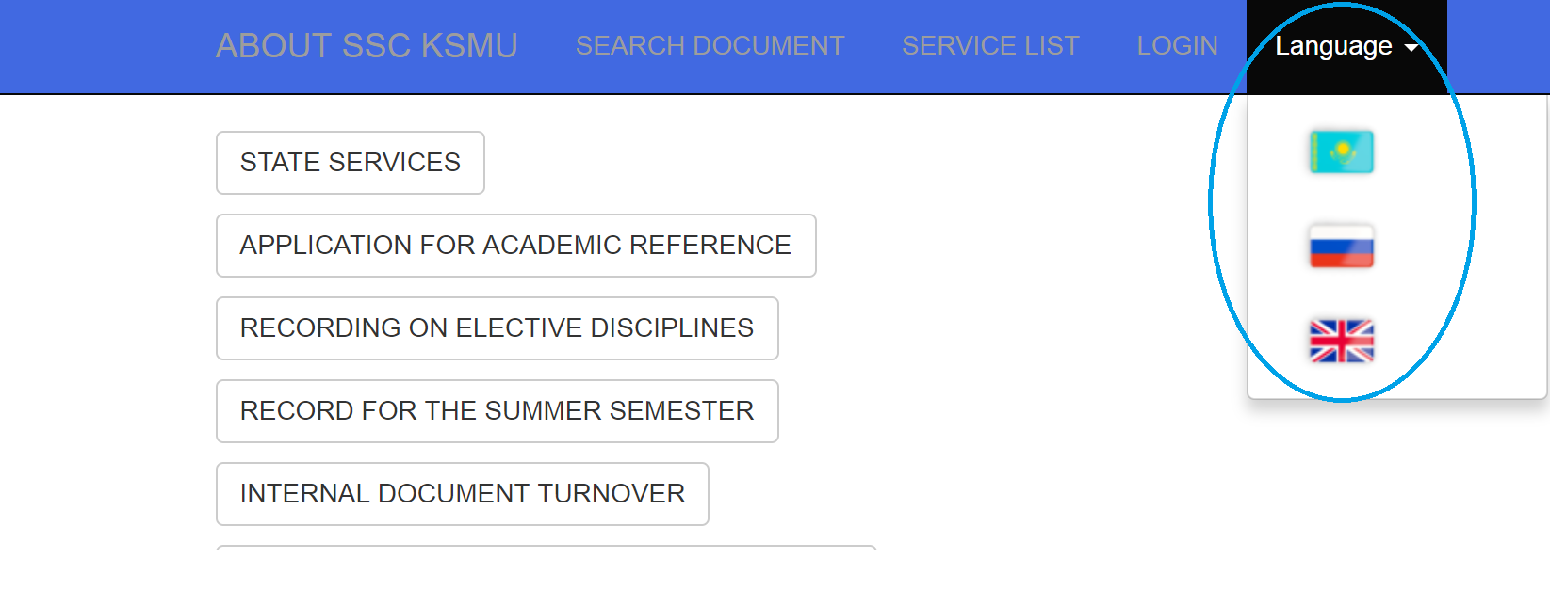
- Sign in: Click the button "LOGIN"

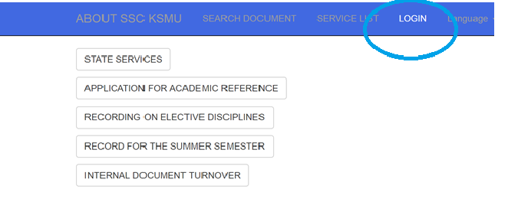
- The student's personal electronic office will be opened:
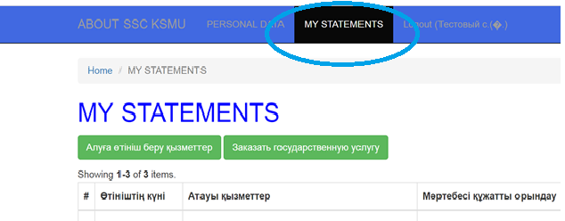
- After opening the personal electronic office of the student, select ПОДАТЬ ЗАЯВЛЕНИЕ НА ПОЛУЧЕНИЕ УСЛУГИ

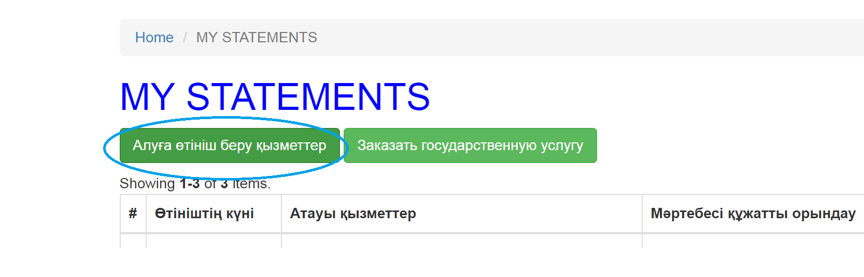
- Choose the list of services
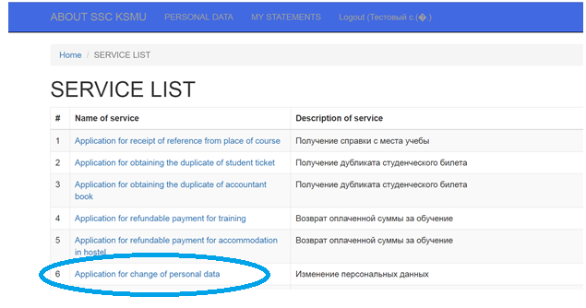
- Application for change of personal data Click on the СФОРМИРОВАТЬ ЗАЯВЛЕНИЕ button
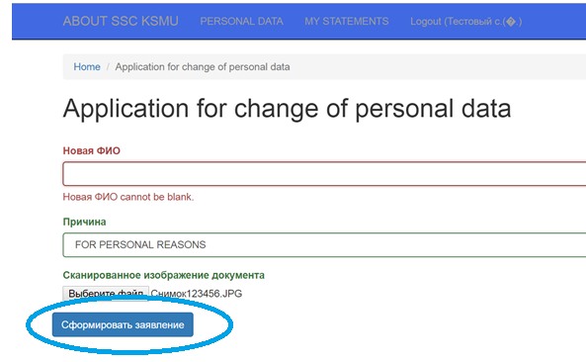

- In the window that opens, check the entered information and click on the ПОДПИСАТЬ И ОТПРАВИТЬ ЗАЯВЛЕНИЕ
