Partner universities from Kazakhstan
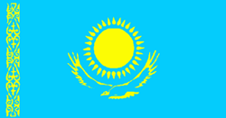

No. |  | Partner university | Type of agreement | Website
1. |  | West Kazakhstan State Medical University named after Marat Ospanov | Memorandum on cooperation in the field of health, medical education and science | www.zkgmu.kz
2. |  | South Kazakhstan State Pharmaceutical Academy | Memorandum on cooperation in the field of health, medical education and science | www.ukgma.kz
3. |  | Kazakh National Medical University named after S. D. Asfendiyarov | Memorandum on cooperation in the field of health, medical education and science | www.kaznmu.kz
4. |  | Taraz Innovation and Humanities University | Memorandum on cooperation in the field of health, medical education and science | http://tigu.kz
5. |  | International Kazakh-Turkish University named after H. A. Yasavi | Cooperation agreement on academic mobility of students | www.turkistan.kz
6. |  | JSC “Medical University of Astana” | Memorandum of cooperation in the field of health, medical education and science | www.amu.kz
7. |  | Kazakh-Russian Medical University | Memorandum of cooperation in the field of health, academic, scientific and cultural cooperation | http://medkrmu.kz/
8. |  | Zhezkazgan University named after O. A. Baikonurov | Memorandum of cooperation in the field of health, academic, scientific and cultural cooperation.  Agreement on a Joint educational program | http://www.zhezu.kz/
9. |  | Karaganda University "Bolashak" | Agreement on mutual cooperation in the provision of educational services in the framework of academic mobility programs | http://www.kubolashak.kz/
10. |  | School of Chemistry and Biology in Karaganda | Cooperation agreement | http://krg.nis.edu.kz/Karaganda/portal/default.aspx
11. |  | SI "Gymnasium No. 38 of Chemistry and Biology" | Cooperation agreement | http://kargoo.gov.kz/content/view/58/978
12. |  | Semey State Medical University | Memorandum on cooperation in the field of health, medical education and science | http://ssmu.kz/ru
13. |  | Central Kazakhstan University | Agreement on mutual cooperation on provision of educational services; Agreement on mutual cooperation on provision of educational services and student academic mobility | http://c-k-a.kz/
14. |  | Pavlodar State University named after T. S. Toraigyrov | Memorandum on cooperation in the field of health, academic, scientific and cultural cooperation | http://psu.kz/index.php?lang=rus
15. |  | North Kazakhstan State University named after Manash Kozybayev | Agreement on cooperation in the field of health, academic, scientific and cultural cooperation | http://www.nkzu.kz/
16. |  | Pavlodar State Pedagogical Institute | Memorandum on cooperation in the field of health, academic, scientific and cultural cooperation | http://www.ppi.kz/
17. |  | Pavlodar State University named after T. S. Toraigyrov | Memorandum of understanding (in the fields of Biology, Chemistry, Physics, Biochemistry, Biophysics,  Instrumentation, Informatics, Information systems, Social work) | http://psu.kz/index.php?lang=rus
Foreign partners
Russian Federation 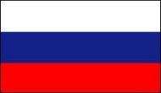
1. |  | Kursk State Medical University | Cooperation agreement | http://www.kurskmed.com/
2. |  | Orenburg State Medical Academy | Memorandum of cooperation | www.orgma.ru
3. |  | Kostroma State University named after N. Nekrasov | Agreement on scientific, educational and cultural cooperation | www.ksu.edu.ru
4. |  | Belarusian State Medical University | Agreement on academic and scientific cooperation and exchange | http://www.bsmu.by/
5. |  | Bashkir State Medical University | Memorandum on cooperation | www.bashgmu.ru
6. |  | Novosibirsk State Medical University | Cooperation agreement | www.ngmu.ru
7. |  | Gomel State Medical University | Memorandum on cooperation | www.gsmu.by
8. |  | Surgut State University | Agreement on academic and scientific cooperation and exchange | www.surgu.ru
9. |  | Kazan State Medical University | Cooperation agreement | www.kgmu.kcn.ru
10. |  | North-Western State Medical University named after I. I. Mechnikov | Memorandum on cooperation | http://szgmu.ru/
11. |  | Siberian State Medical University | Memorandum on cooperation | www.ssmu.ru
12. |  | Russian Medical Academy of postgraduate education | Agreement on scientific and educational cooperation | http://www.rmapo.ru/
13. |  | Sechenov University | Cooperation agreement | http://www.mma.ru/
14. |  | Altai State Medical University | Memorandum on cooperation in the field of health, academic, scientific and cultural cooperation | http://www.agmu.ru/
15. |  | Tyumen State Medical University | Cooperation agreement | http://www.tyumsmu.ru/index.html
16. |  | Ryazan State Medical University named after academician I. P. Pavlov | Cooperation agreement | https://www.rzgmu.ru/
17. |  | Perm State Medical University named after Academician E. A. Wagner | Memorandum on cooperation in the field of health, academic, scientific and cultural cooperation | http://www.psma.ru/en/
18. |  | North Ossetian State Medical Academy | Memorandum on cooperation in the field of health, academic, scientific and cultural cooperation | http://sogma.ru/
19. |  | Ural State Medical University | Agreement on international cooperation in the field of science and education | http://www.usma.ru/
20. |  | Rostov State Medical University | Treaty on international cooperation | http://rostgmu.ru/
21. |  | Kazan State Medical Academy | Memorandum on cooperation in the field of health, academic, scientific and cultural cooperation | https://kgma.info/
22. |  | Omsk State Medical University | Memorandum on cooperation | http://omsk-osma.ru/
23. |  | Smolensk State Medical University | Memorandum on cooperation in the field of health, medical education and science | http://smolgmu.ru/
24. |  | Chechen State University | Agreement on cooperation in the field of health, academic, scientific and cultural cooperation | https://www.chesu.ru/
25. |  | A. I. Evdokimov Moscow State University of Medicine and Dentistry. | Agreement on cooperation in the field of health, academic, scientific and cultural cooperation | http://www.msmsu.ru/
26. |  | Volgograd State Medical University | Agreement on cooperation in the field of academic, scientific and cultural cooperation | http://www.volgmed.ru/ru/
27. |  | Altai State University | Memorandum on cooperation in the field of academic, scientific and cultural cooperation | https://www.asu.ru/
28. |  | Vladimir State University named after Alexander and Nikolay Stoletovs | Cooperation agreement | http://www.vlsu.ru/
29. |  | Voronezh State Medical University named after N.N. Burdenko | Cooperation agreement | http://www.vsmaburdenko.ru/
30. |  | Saint-Petersburg State Pediatric Medical University | Cooperation agreement | http://gpmu.org/
31. |  | Derzhavin Tambov State University | Agreement on Mutual Cooperation | http://www.tsutmb.ru/
Ukraine 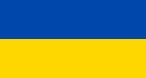
1. |  | Kharkiv National Medical University | Agreement on the intentions of mutual cooperation in the field of medical education and science | http://www.knmu.kharkov.ua/
2. |  | Sumy State University | Memorandum of cooperation | http://sumdu.edu.ua/ukr/
3. |  | Zaporizhzhya State Medical University | Memorandum of understanding for academic cooperation | http://zsmu.edu.ua/
4. |  | Bukovininan State Medical University | Bilateral Cooperation Agreement | https://www.bsmu.edu.ua/en/
5. |  | Shupyk National Medical Academy on Postgraduate Education | Memorandum on cooperation in the field of health, academic, scientific and cultural cooperation | https://www.nmapo.edu.ua/en/
Belarus 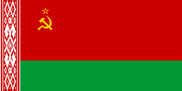
1. |  | Belarusian Medical Academy of Post-Graduate Education | Cooperation agreement | https://belmapo.by/
2. |  | Vitebsk State Order of Peoples' Friendship Medical University | Cooperation agreement | https://www.vsmu.by/en/
3. |  | Gomel State Medical University | Memorandum on cooperation | http://www.gsmu.by/
4. |  | Belarusian State Medical University | Agreement on academic and scientific cooperation and exchange | https://www.bsmu.by/
5. |  | Grodno State Medical University | Agreement on Cooperation | http://www.grsmu.by/
Armenia 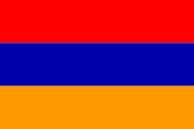
1. |  | International University of Eurasia | Memorandum on cooperation in the field of health, academic, scientific and cultural cooperation | http://eiu.am/
2. |  | Yerevan State Medical University after Mkhitar Heratsi | Memorandum on cooperation in the field of health, academic, scientific and cultural cooperation | http://www.ysmu.am/
3. |  | Russian-Armenian University | Agreement about academic mobility programme | http://www.rau.am/rus/
Sweden 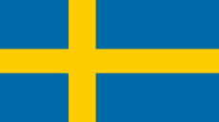
1. |  | University of Gothenburg, Sahlgrenska Academy | Cooperation agreement | https://www.gu.se/
2. |  | Orebro University | Agreement on joint scientific consultation of doctoral students, a Memorandum of cooperation | https://www.oru.se/
France
1. |  | L'Institut National de la Recherche Agronomique. Centre de tours. Unité Mixte de Recherches INRA-CNRS-Université de Tours - IFCE. Physiologie de la Reproduction et des Comportements. | Memorandum of understanding | https://www.tum.de/
Germany 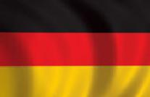
1. |  | Technical University of Munich | Agreement on joint scientific consulting of doctoral students | https://www.unipg.it/,  https://www.unistrapg.it/
Italy 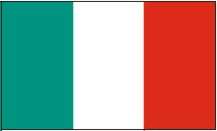
1. |  | University of Perugia | Memorandum on cooperation
2. |  | The University of Milan | Memorandum of Understanding | http://mse.mef.unizg.hr/
3. |  | University of Catania | Agreement on Cooperation | https://www.unict.it/
Croatia 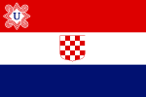
1. |  | University of Zagreb, School of Medicine | Memorandum of cooperation, scientific advice | http://usmf.md/ru/
Moldova 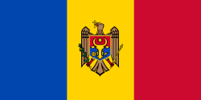
1. |  | State University of Medicine and Pharmacy “Nicolae Testemiţanu” | Agreement on scientific and practical cooperation | http://www1.mc.ntu.edu.tw/EN/index.html
Taiwan 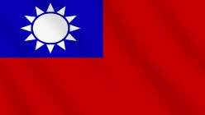
1. |  | National Taiwan University, School of Medicine | Memorandum of cooperation. Agreement on scientific exchange (advising doctoral students) | http://www.ylsy.edu.cn/
China 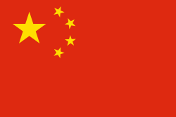
1. |  | Yili Normal University | Cooperation agreement
2. |  | Beijing University of Chinese Medicine | Memorandum of understanding | http://bdti.uz/index.php/uz/
Uzbekistan 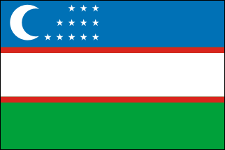
1. |  | Bukhara State Medical Institute | Memorandum of understanding | http://pharmi.uz/?lang=en
2. |  | Samarkand State Medical Institute | Memorandum of cooperation
3. |  | Tashkent Pharmaceutical Institute | Memorandum on cooperation in the field of health, medical education and science | http://www.tnu.tj/index.php/ru/
4. |  | Tashkent State Dental Institute | Memorandum on cooperation in the field of health, academic, scientific and cultural cooperation | http://tsdi.uz/
Tajikistan 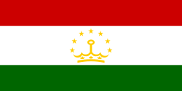
1. |  | Tajik National University | Memorandum of cooperation | http://www.tnu.tj/index.php/ru/
2. |  | Avicenna Tajik State Medical University | Memorandum of cooperation | http://www.atsmu.net/
Finland 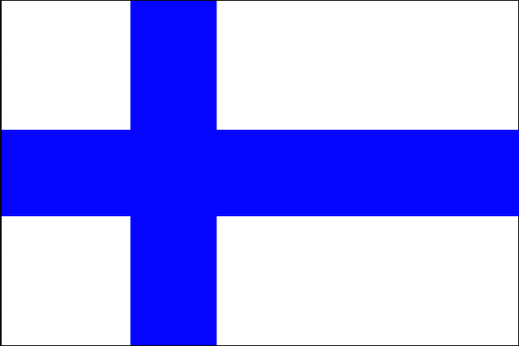
1. |  | Lahti University of Applied Sciences | Memorandum of cooperation | http://www.lamk.fi/Sivut/default.aspx
Malaysia 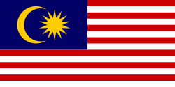
1. |  | International Medical University | Memorandum of cooperation | http://www.imu.edu.my/imu/
Kyrgyzstan 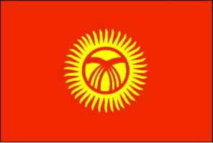
1. |  | Kyrgyz State Medical Academy | Memorandum of cooperation | http://www.kgma.kg/index.php/ru/
2. |  | International School of Medicine | Memorandum of understanding | http://imu.kg/
3. |  | Kyrgyz Russian Slavic University named after the first President of Russia B. N. Yeltsin | Cooperation agreement | https://www.krsu.edu.kg/index.php?lang=en
4. |  | Jalal-Abad State University | Memorandum on cooperation in the field of health, academic, scientific and cultural cooperation | https://jasu.kg/
Turkey 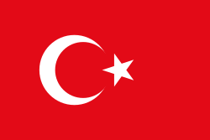
1. |  | Ataturk University | Memorandum of understanding | https://www.atauni.edu.tr/
2. |  | Adiyaman University | Mevlana Agreement on exchange of students and teachers | https://adiyaman.edu.tr/
3. |  | University of Medical Sciences | Memorandum of understanding | https://basvuru.sbu.edu.tr/
Poland
1. |  | Medical University of Lodz | Memorandum of cooperation | http://umed.pl/
2. |  | Medical University of Lublin | Mutual cooperation agreement between the Lublin MU and KMU | http://www.umlub.pl/
Bulgaria 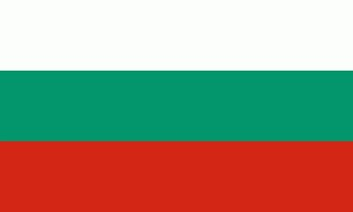
1. |  | Sofia University St. Kliment Ohridski | Cooperation agreement | https://www.uni-sofia.bg/eng
2. |  | Medical University of Plovdiv | Memorandum on cooperation | https://mu-plovdiv.bg/en/
Greece 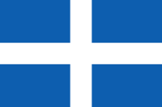
1. |  | Aristotle University of Thessaloniki | Agreement on cooperation in the field of health, academic, scientific and cultural cooperation | https://www.auth.gr/
2. |  | University of Piraeus | Memorandum of understanding | http://www.unipi.gr/unipi/el/
Spain 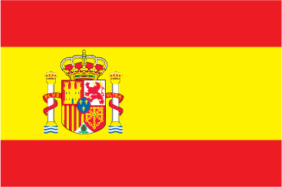
1. |  | Graduate School of Management in Barcelona | Memorandum of cooperation in the field of health, academic, scientific and cultural cooperation agreement on a Joint educational program | http://www.gsmbarcelona.eu/
2. |  | University of Madrid | Agreement on academic, scientific and cultural cooperation | https://www.udima.es/
India 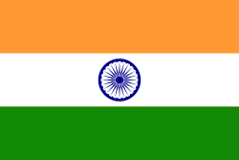
1. |  | International Institute of Medical Sciences | Agreement on the Joint educational program | https://nimsuniversity.org/nu/national-institute-of-medical-sciences-research-nims-medical-college-and-hospital-2/
2. |  | Modern Institute of Management Education Society | Memorandum on cooperation in the field of health, medical education and science | http://www.mibmpune.com/
Thailand 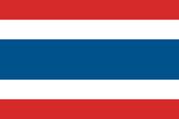
1. |  | Srinakarinwirot University | Memorandum of cooperation | https://www.swu.ac.th/en/
Georgia 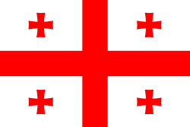
1. |  | David Tvildiani Medical University | Memorandum of cooperation | http://www.dtmu.ge/index.php?Cat=testimonials&lang=3
2. |  | Kutaisi Akaki Tsereteli State University | Memorandum of cooperation | https://atsu.edu.ge/
3. |  | Batumi Shota Rustaveli State University | Memorandum on agreement | https://bsu.business.site/
Scotland 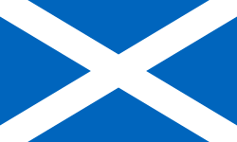
1. |  | University of Dundee | Memorandum of cooperation | https://www.dundee.ac.uk/
Latvia
1. |  | University of Latvia | Memorandum of cooperation | https://www.lu.lv/
USA 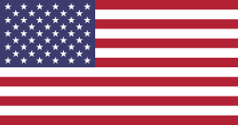
1. |  | University at Albany | Memorandum of understanding for academic, scientific and cultural cooperation | https://www.albany.edu/
Great Britain 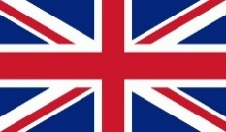
1. |  | University of Leicester | Memorandum of understanding | https://le.ac.uk/
Netherlands 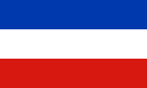
1. |  | Maastricht University | Memorandum of cooperation in the field of health, academic, scientific and cultural cooperation | https://www.maastrichtuniversity.nl/
Vietnam 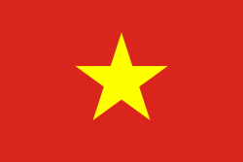
1. |  | Hanoi Medical University | Memorandum on cooperation in the field of academic, scientific and cultural cooperation | http://www.hmu.edu.vn/news/default.aspx
Croatia 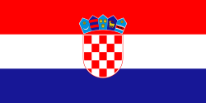
1. |  | University of Zagreb, School of Medicine | Bilateral cooperation agreement between Zagreb University, school of Medicine and Karaganda state medical University | http://mef.unizg.hr/en/
Kenya 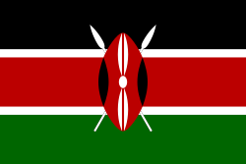
1. |  | University of Nairobi | Memorandum of understanding | http://www.uonbi.ac.ke/
Roumania 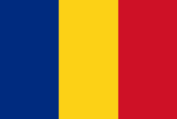
1. | Alexandru Ioan Cuza University |  | Agreement on Cooperation |  | http://www.uaic.ro/
2. | Iuliu Hațieganu University of Medicine and Pharmacy |  | Agreement on Cooperation |  | http://www.umfcluj.ro/
Hungary 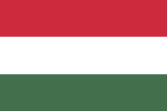
1. | University of Pecs |  | Agreement about cooperation on students and academic staff exchange |  | https://international.pte.hu/
Japan 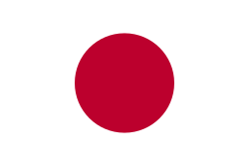
1. | University of Shimane |  | Memorandum of cooperation in the field of health, academic, scientific and cultural cooperation |  | https://www.shimane-u.ac.jp/
Portugal 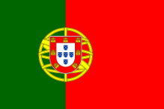
1. | University of Porto |  | Memorandum of cooperation in the field of health, academic, scientific and cultural cooperation |  | https://sigarra.up.pt
Slovenia 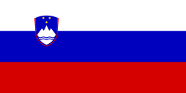
1. | University of Ljubljani, Medical faculty |  | Agreement on Cooperation |  | www.uni-lj.si

