Preparation of personnel reserve
Within the framework of distribution of information on the project and preparation of the personnel reserve of the university, the Human Resources Management Department (HRMD) together with a department of medical education developed a program and a plan of preparation of reserve staff to fill the managerial position, and conducted training sessions with this group of employees.
The heads of structural divisions of the university also took part in conducting the classes. 21 employees were trained under this program.
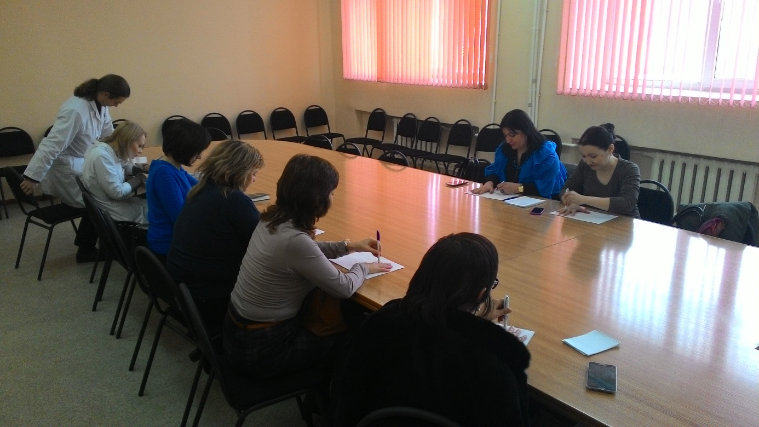
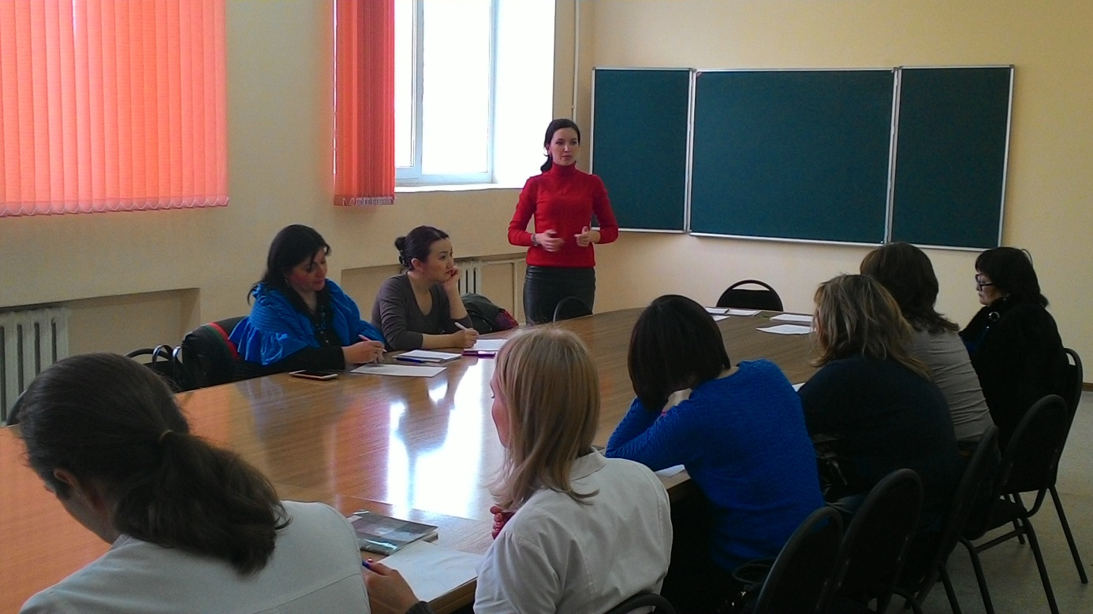

Thematic plan of lectures on the program of preparation of reserve personnel to fill the managerial positions of KSMU for 2015 - 2016
№ | Topic | Lecturer | Date of conduction | Time of conduction | Place of conduction
I | Strategic planning in education organizations
 | Strategy development process | Muratova A.Z.,  Director of Department of Strategy and Development | 21.11.15 | 8.30 | 40 Gogol Street, 325 classroom
 | How to achieve the desired result and ensure its stability
 | Planning strategy and analysis. Intelligence cards.
II | Implementation of principles of Bologna Process
 | Activities to implement the principles of the Bologna Process | Nurgalieva A.S.,  Head of International Cooperation and Bologna Process Department | 12.12.15 | 9.00 | 40 Gogol Street, 325 classroom
 | Academic mobility programs
 | Erasmus Plus Program
III | Quality management in medical organization
 | Quality management standards | Tuzankina T.R.,  Head of Quality Management System Department | 09.01.16 | 9.00 | 40 Gogol Street, 339 classroom
 | Evaluation of effectiveness of quality management
 | Customer orientation
IV | Accreditation of medical education organizations
 | Institutional self-assessment of university activities | Muratova A.Z.,  Director of Department of Strategy of and Development | 05.12.15 | 8.30 | 40 Gogol Street, 325 classroom
 | Procedure for accreditation of educational programs
 | Criteria for accreditation of university
V | Management in medical education
 | General principles of management | Toleubekov K.K., Dean of GM and Dentistry  Tashkenbaeva V.B., Dean of Internship | 19.12.15 | 9.00 | 40 Gogol Street, 325 classroom 325
 | Description and analysis
 | Problem solving
VI | Fundamentals of HR Management
 | Leadership and ethics | Doskozhin D.M.,  Director of HRMD | 23.01.16 | 10.00 | 40 Gogol Street, 339 classroom
 | Personnel management
 | Leadership in system of healthcare
VII | Organization of educational process
 | Credit technology.  Dublin descriptors.  Problems of introduction of credit technology | Tashetova A.B. Director of Department of Educational and Methodological Work (DEMW)  Riklefs I.M., Head of Methodical Cabinet of DEMW | 28.11.15 | 10.00 | 40 Gogol Street, 325 classroom
 | Methodical work at departments
 | Organization and implementation of current boundary control of academic achievement under credit technology (practical training, SIWTC, SIW, classes at the CPS)
VIII | Design, development, implementation of scientific grants
 | Search for grants | Turmukhambetova A.A., Vice-Rector for scientific work  Edilbaeva T.T., Head of Department of Management of Science and Innovation Activity | 30.01.16 | 10.00 | 40 Gogol Street, 339 classroom
 | Organization of research work: planning, development and implementation of grants
 | Preparation of application for grant
IX | Integration of evidence-based medicine into educational program
 | How to motivate EBM study? | Kaliyeva Sh.S., Head of Department of Clinical Pharmacology and EBM | 16.01.16 | 9.00 | 40 Gogol Street, 339 classroom
 | Assessment of methodological quality
 | Introduction of evidence-based medicine

