Mission reports on the project TEMPUS (monitoring) in September 2014
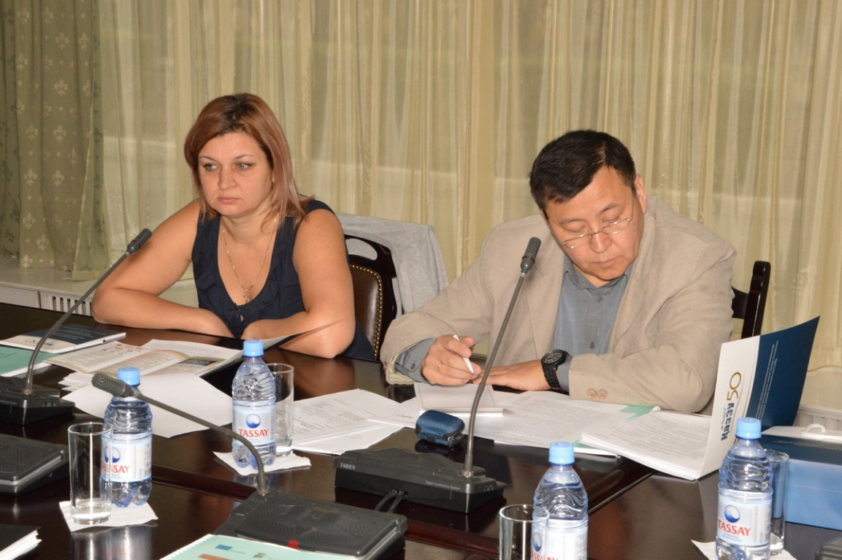
In September 3 – 4, 2014 in Almaty on the basis Ryskulov Kazakh University of Economics was meeting monitoring according to the TEMPUS «Promoting educational organizations through development of people» program. Staff of our university became participants of monitoring: Director of the Center of Human Resources Management – TEMPUS project coordinator D. M. Doskozhin and Head of HR – project manager E.A. Kravtsiv. During monitoring, which was carried out by Sh.U. Tasbulatowa, National Erasmus Office coordinator, was discussed the following questions: «Efficiency of realization of the first stage of the project», «Productivity at the moment». TEMPUS project coordinator D. M. Doskozhin presented the report «Potential influence of the project». According preliminary results of monitoring which were summed up by Sh.U. Tasbulatowa, National Erasmus Office coordinator, work on the project was recognized as satisfactory.
Participants of monitoring visited the resource center of KazEU of T. Ryskulov, and also met administrative personnel of the project.

