REPORT on the mission of the TEMPUS project (training seminar)
June 7-10, 2016 (Sweden, Stockholm)
On June 7-10, 2016 was held a training seminar "Human Resource Management in Higher Education" at KTH Royal Institute of Technology, Stockholm.
Employees of our university D. Doskozhin, Director of HR management Department, TEMPUS Project Coordinator and N. Bek, Specialist of HR Management Department, Project Manager, were the participants of the event.
The conference was also attended by the partners:
· Polytechnic University of Catalonia, Barcelona, Spain
· Higher Technical Institute, Lisbon, Portugal
· Royal Institute of Technology, Stockholm, Sweden
· State University of Ellijay, Georgia
· University of Kutaisi, Georgia
· Armenian State University of Economics, Armenia;
· Russian-Armenian (Slavonic) University of Armenia
· American University of Armenia
· T.Ryskulov New Economic University, Kazakhstan, the Coordinator
· Kazakh Academy of Transport and Communication, Kazakhstan
· S.Toraigyrov Pavlodar State University, Kazakhstan
During the training seminar HR managers of KTH university of various levels shared work experience in the field of human resources management in KTH.
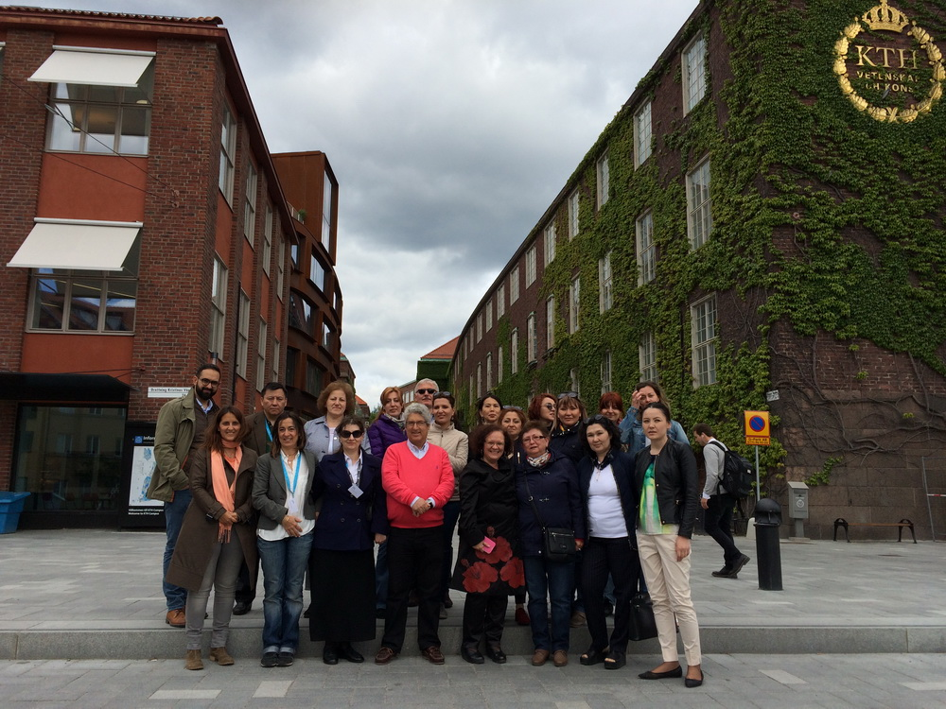
Annica Froberg, the Personnel Director and Lotta Gustavsson, the Personnel Manager have familiarized the participants of the seminar with the principle of work with human resources in KTH and in Sweden in general. Also, Lotta Gustavsson and Viktor Kordas have told about personal policy in work with the personnel in KTH, cooperation as a means of KTH development. The invited speaker Isabel Goncalves, the Coordinator of the tutorial office of Technical University of Lisbon (IST) conducted the training on Coaching.
During all days of the training seminar, in the second half of the day, were held discussion and correction of strategic plans of all higher education institutions, members of the consortium, developed within the frameworks of PEOPLE project implementation. In the course of the individual speech of the university representative the weaknesses of the plan were revealed and the Project Coordinator Alicia Berlanga made recommendations for further development of the strategic plan of each university.
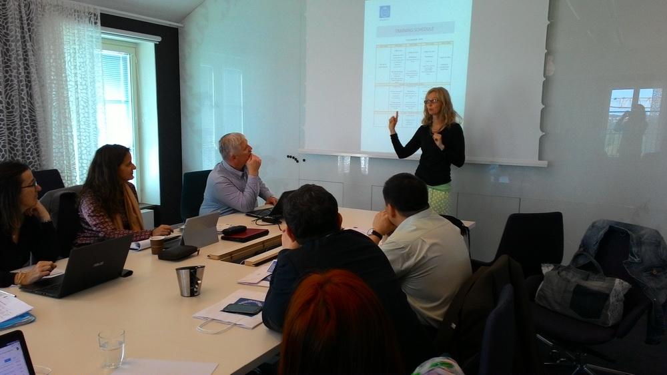
For the working group of the participants the organizers of the seminar conducted an excursion on the office building of KTH so the participants could see how workplaces of the University staff are organized, ask the questions of interest about the personnel management and receive practical answers by the example of work in KTH.
In the last day of the seminar was held a meeting of coordinators of institutions of higher education under PEOPLE project, where were discussed further actions within the program and required reports for the European Commission.
Upon the termination of the training seminar all the participants have been awarded the certificates.

